Cmpe 240

Digital Design

Project 2: Stack and Queue Design

Design Document

Name: Emin Şenay

ID: 2002103907

Instructor: Arda Yurdakul

Assistants: Ömer Korçak, Atay Özgövde, Serdar Salı

Introduction

This document is about the digital design of stack and queue. In the first part, queue will be explained. After the layout of the queue, stack part will start. In the last part, the layout of the pulse catching circuit will be given since it is used for counter in our project.

Queue

In my design, queue contains two main parts. The first part is 3 bit up / down counter and the second part is shift register. First, I will explain the counter part.

3 bit Up / Down Counter

There are four inputs, which are up, down, CLR and clock. When clock is rising, if up is 1, counter increments its output by 1, and if down is 1, counter decrements its output by 1. It does not do anything when both of the inputs are either 0 or 1. Counter gives three bit output, Q[2:0] between “000” and “100”. The other outputs are err, full and empty. Full is 1 when the Q is “100” and empty is 1 when the Q is “000”. Err turns on when the clock is full and up is 1 and when the clock is empty and down is 1.

Shift Register

The name of this part is shift register, because the connections of D Flip Flops resembles the shift register, but it is an enhanced version of it since the inputs of the multiplexer connected to each D Flip Flop are different than the shift register and also the output is different.

The inputs of the shift register part are INP, sel1 and the counter outputs, and the output is the Output which contains the requested output by Pop. There are three parts of the shift register, input multiplexer part, Flip Flop part and output multiplexer part:

Input multiplexer part: First, select input sel needs to be explained: The inputs of the shift registers must be shifted when Push input is 1, Pop input is 0 and the register is not full. So sel is simply the AND of them. When this condition is satisfied, flip flops must take the next output. Therefore, INP is connected the mux of the first flip flop and the output of the previous flip flop is connected to next muxes. When this condition is not satisfied, the input in the flip flop must remain same, output of the flip flop is connected the other port of the mux.

Flip Flop Part: Input of the flip flop is connected to the output of the mux and the clock is the clock which is made from the pulse catching circuit.

Output multiplexer part: The outputs of the counter are connected to the select inputs. There is also an enable input, which enables the mux when Pop input is 1, Push input is 0 and err output of the clock is 0. First four inputs are connected to the outputs of t he flip flops and the others are grounded. The mux gives the corresponding output when user wants to pop input from the queue. The circuit does not do anything when both inputs are either 0 or 1.

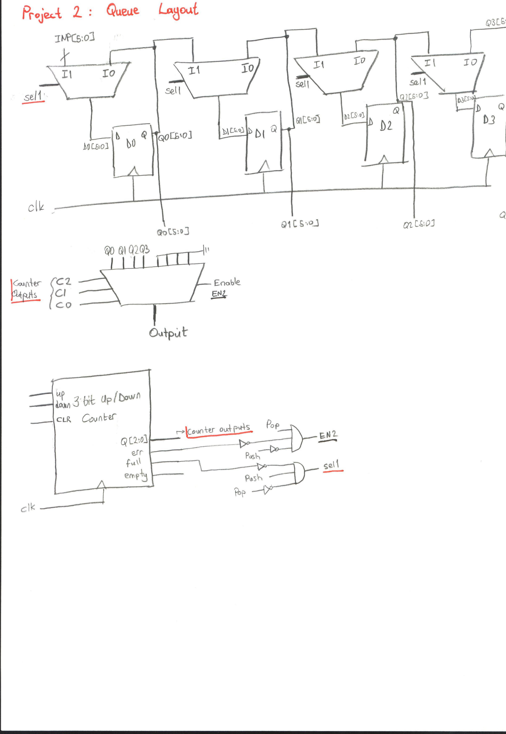

Stack

Stack contains the same two main parts of the queue, which are 3 bit up / down counter and the shift register. Counter part is exactly the same as the counter used in the queue design. The register part is different, so it will be explained here:

Shift Register

The inputs and the outputs of the register is the same as the register used in queue design. Also, input multiplexer, Flip Flop and the output multiplexer parts are resembles with the other, too. However, inputs entering the muxes are different.

Input multiplexer part: First, select inputs S2, S1 and S0 need to be explained: When pop is 1, the inputs of the shift registers should be shifted to left, when push is 1, they should be shifted to right and also when both of them are 0 or 1, or when counter output is 4 and push is entered or counter output is 4 and not pop entered, flip flops must hold the input. S2 controls the last part, S1 is Push and S0 is Pop. The corresponding inputs of the mux are: The output of the same input (push and pop are 0), the output of the next input (pop), the output of the previous input (push), the output of the same input (push and pop are 1) and the output of the same input (last condition).

When user pops an input, the output at Q0 should be returned. However, it does not hold this value for long time because the output of the next input will be assigned to Q0 when the clock rises. Also, third flip flop will not hold any value when pop is entered. So, the output Q0 is connected to input of the 3rd flip flop and the output is taken from here.

Flip Flop Part: Input of the flip flop is connected to the output of the mux and the clock is the clock which is made from the pulse catching circuit.

Output multiplexer part: The output of the third flip flop is connected to the input 1 of the mux and the other input is grounded. When there is not error, Pop is 1 and Push is 0, Ouptput is displayed.
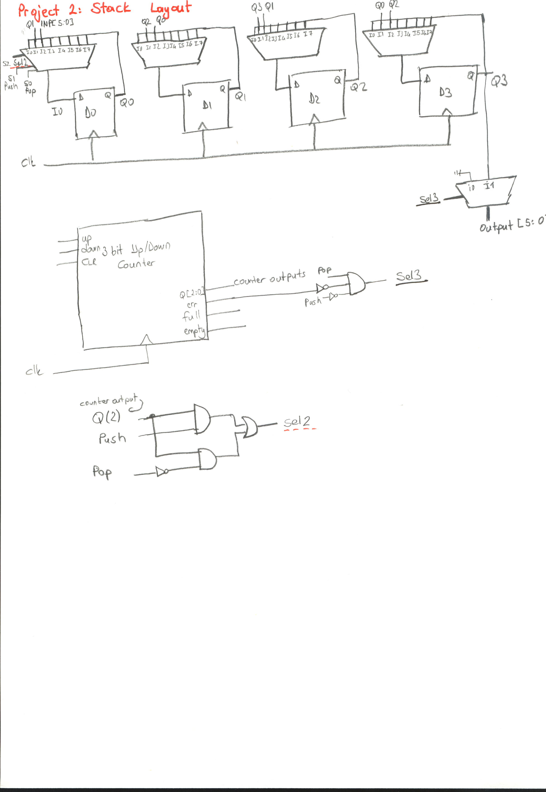

Pulse Catching Circuit
